*How to use report URLs to download OASIS data*



Open-Access Same Time Information System (OASIS)

**Version 1.1**

January 20, 2022

Revision History

| **Date** | **Version** | **Description** | **Author** |
| --- | --- | --- | --- |
| 01/13/2022 | 1.0 | Initial version | Sandhya Balasubramanian |
| 01/20/2022 | 1.1 | Added frequently accessed reports section | Sandhya Balasubramanian |
|  |  |  |  |

Table of Contents

1. Purpose 3

2. Navigation Steps 3

2.1 CAISO Public Site 3

2.1.1: Accessing CAISO’s Public site 3

2.1.2: Accessing ISO’s Developer Site 3

2.2 Navigation within ISO’s Developer Site 4

2.2.1: Navigating to Application Documentation 4

2.2.2: Locating the Application Technical Specifications 4

2.2.3: Accessing the Quick Links Document 5

2.2.4: Finding the Report URL 5

2.2.5: Triggering the Report URL to download data 5

2.2.6: Picking your downloaded file to review or save 6

3. Getting URLs from OASIS 6

4. Frequently Used Price & MW Reports 7

4.1 Frequently Used Reports on Price 7

4.2 Frequently Used Reports on MWs 8

5. Appendix 9

Locational Marginal Pricing Reports 9

Shadow Prices Reports 9

Ancillary Services Prices Reports 10

System Demand Reports 10

Transmission Reports 10

Ancillary Services Reports 10

# Purpose

The purpose of this document is showcase the ease with which data from OASIS reports can be downloaded using the report URL. The URLs are Application Programming Interface (API) calls to the backend containing the parameters for which the specific report is being queried. The URLs for a CSV downloadable format differs from the XML format. A user can use these URLs, change the parameter value to download the report for the desired trade date and other parameters in the specified format.

The document guides the users through the navigation steps and further how to access the URL examples.

# Navigation Steps

The steps below help the end user navigate from the CAISO public site to ISO’s Developer Site which houses the URL examples document, which very handily displays the list of URLs in a single document.

## CAISO Public Site

2.1.1: Accessing CAISO’s Public site

In your browser, type [www.caiso.com](http://www.caiso.com) to get to CAISO’s public site

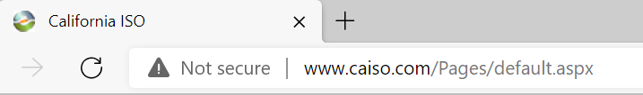

### 2.1.2: Accessing ISO’s Developer Site

From CAISO’s public site, scroll to the bottom of the page and click the link labelled ‘Developer’ to get to [CAISO’s developer site](https://developer.caiso.com/). You can also bookmark this page on your browser (<https://developer.caiso.com/>).

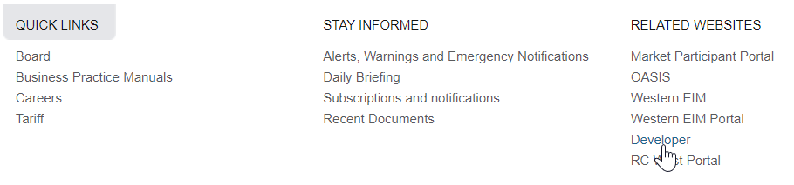

Note: ISO’s Developer site requires a user to register to access the contents. You will need to set up a login and a password. (This access does not require a certificate authentication.)

## Navigation within ISO’s Developer Site

### 2.2.1: Navigating to Application Documentation

From the ISO’s Developer main page, navigate to Apps -> OASIS

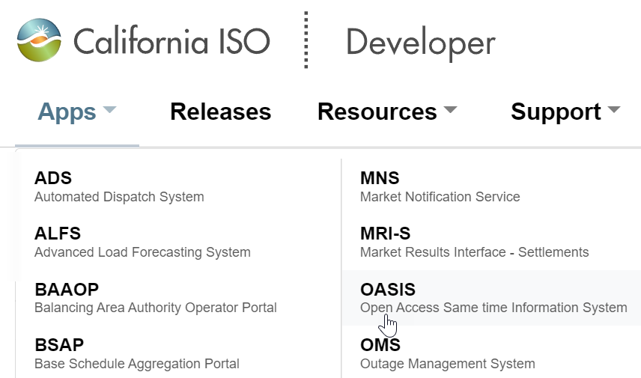

### 2.2.2: Locating the Application Technical Specifications

Scroll down to the ‘Tech Specs’ section and click on the link to the ‘Examples’ document. You can get detailed information about the report contents in the ‘Interface Specification’ document.

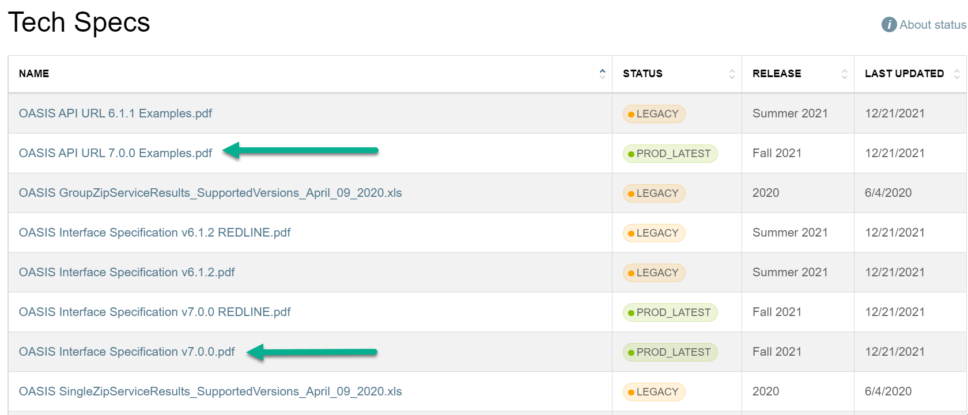

### 2.2.3: Accessing the Quick Links Document

You have the ability to download data based on a trade date (group zip) and some high level parameters or drill down to a more detailed level (single zip). Depending on your specific need select the appropriate section.

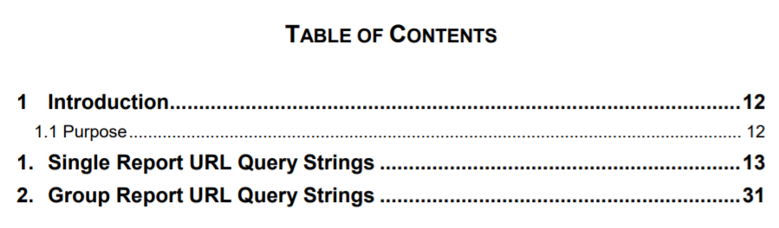

### 2.2.4: Finding the Report URL

From the section, get to the report you are interested in. Select the URL and copy it. (Do not click since you have to input your parameter values.)

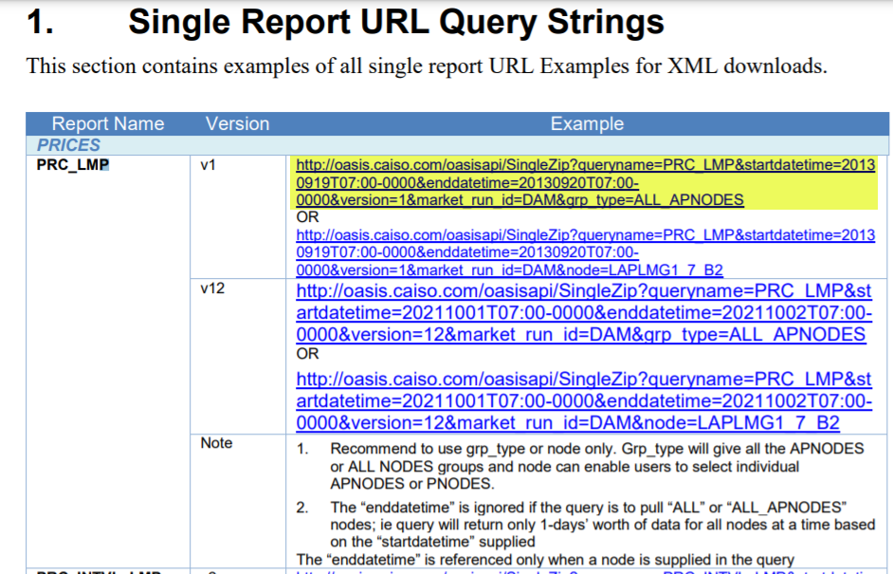

Tip: Some users may find it easier to download the document and then work with this. Please remember to use the latest document

### 2.2.5: Triggering the Report URL to download data

This can be done in 3 ways:

2.2.5.1: Paste the URL in your browser and change the values.



2.2.5.2: Paste the URL in a Word and Excel document as a hyperlink, change the values and click the link to get your report. E.g.

[http://oasis.caiso.com/oasisapi/SingleZip?**resultformat=6**&queryname=PRC_LMP&version=12&startdatetime=20220112T08:00-0000&enddatetime=20220113T08:00-0000&market_run_id=DAM&grp_type=ALL_APNODES](http://oasis.caiso.com/oasisapi/SingleZip?resultformat=6&queryname=PRC_LMP&version=12&startdatetime=20220112T08:00-0000&enddatetime=20220113T08:00-0000&market_run_id=DAM&grp_type=ALL_APNODES)

#### Tips While Using Quick Links:

1. During the DST timeframe, use T07 instead of T08.
2. If you want the output in a csv format then set resultformat = 6. For XML, use resultformat = 5.

### 2.2.6: Picking your downloaded file to review or save

Once the system processes your request a zip file will be provided back. The zip file that contains the results of your API request will appear in the bottom of your screen.

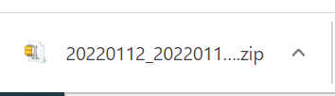

Note: If you get any errors, please refer the ‘Interface Specification’ document highlighted in Step 2.

# Getting URLs from OASIS

Alternatively, you can use the [OASIS application](http://oasis.caiso.com/) to download your report data from the UI. To do this, please click on the OASIS link at the bottom of the [CAISO website](http://www.caiso.com).

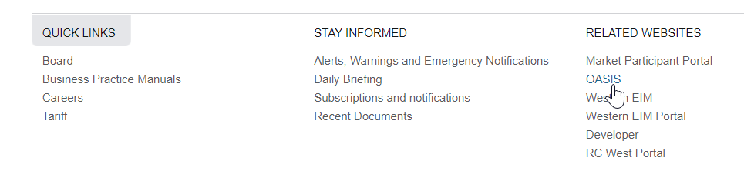

When you use [OASIS](http://oasis.caiso.com/) and navigate to your favorite reports to download data, you can get your favorite URLs from the pop-up that come up when you click the download button. The URL on this window is the same URL in the examples document and Technical Specifications. You can copy and save this URL as well for later use.

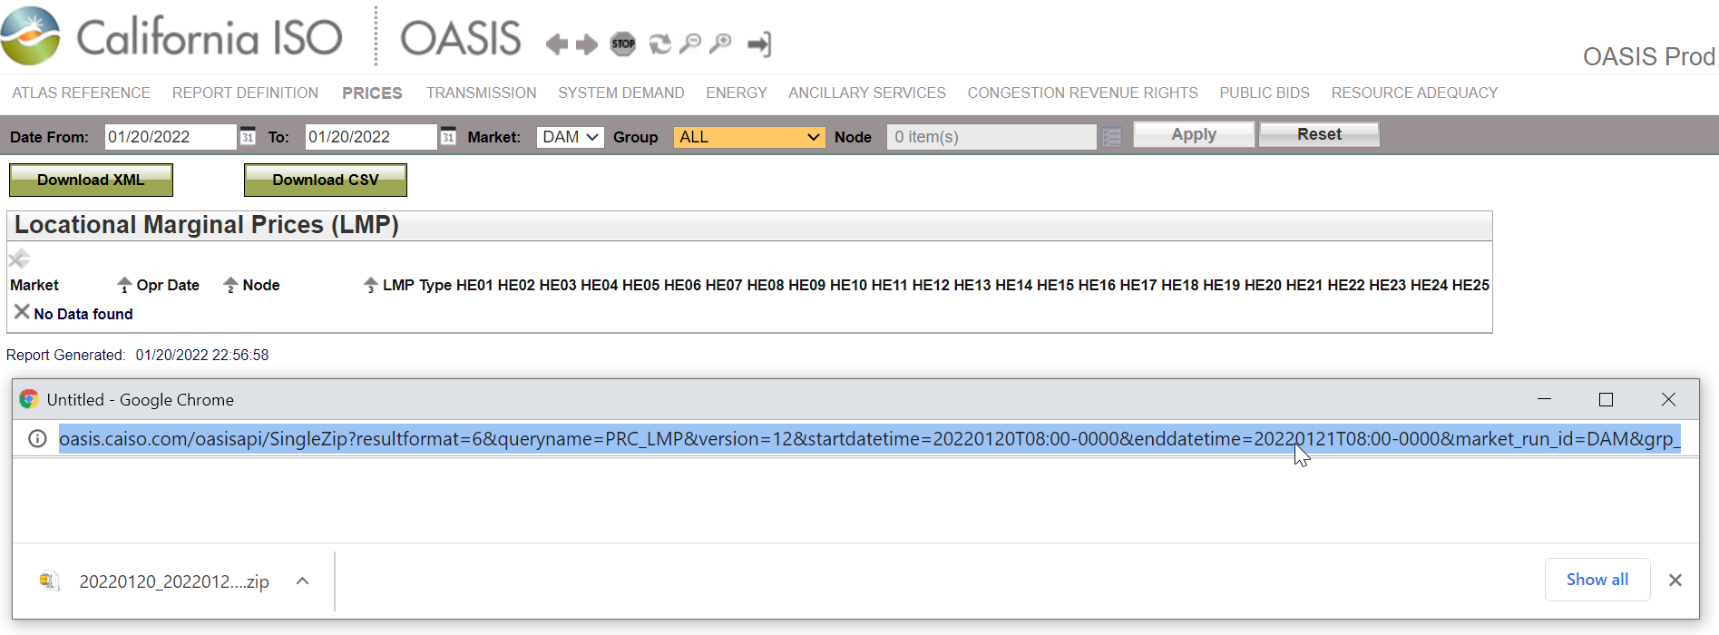

# Frequently Used Price & MW Reports

This section lists some frequently used OASIS reports on prices and megawatts (MWs).

**Important:** Please navigate to the OASIS application for a comprehensive listing of reports and refer to the detailed explanation regarding these reports in the application’s Interface Specification document a.k.a. Technical Specifications. The [Interface Specifications document](https://developerint.oa.caiso.com/Artifacts/OASIS/TechSpecs/OASIS%20Interface%20Specification%20v7.0.0.pdf) on CAISO’s Developer site can be accessed once a user creates a login and password to CAISO’s developer site.

OASIS reports are available by each market, listed as follows:

* Day-Ahead (DAM) / Integrated Forward Market (IFM)
* Real-Time Market (RTM)
  + 15 Minute Market (FMM) / Real-Time Pre-Dispatch (RTPD)
  + 5 Minute Dispatch (RTD)

## 4.1 Frequently Used Reports on Price

The table below lists some of the popular OASIS reports on market prices with the relevant market type and text to search for in the [Examples](https://developerint.oa.caiso.com/Artifacts/OASIS/TechSpecs/OASIS%20API%20URL%207.0.0%20Examples.pdf) document.

| **Report Type** | **Market Type** | **Link in Examples** | **Comments** |
| --- | --- | --- | --- |
| Locational Marginal Price (LMPs) | DAM / IFM | PRC_LMP | Includes its breakdown (loss, energy, congestion) at a specific node level or for all nodes |
| RTPD or 15 minute market | PRC_RTPD_LMP |
| RTD or 5 minute market | PRC_INTVL_LMP |
| Scheduling Point/Tie LMPs | DAM / IFM | PRC_SPTIE_LMP | Includes its breakdown (loss, energy, congestion). Use the appropriate URL for the desired market results |
| RTPD or 15 minute market |
| RTD or 5 minute market |
| Residual Unit Commitment (RUC) Prices | DAM / IFM | RUC_LMP_GRP |  |
| Shadow Prices – Nomogram/ Branch | DAM | PRC_NOMOGRAM | Use the appropriate URL to get results from DAM, RTPD / 15 minute market |
| RTPD or 15 minute market |
| Shadow Prices – Intertie Constraint | DAM | PRC_CNSTR | Use the appropriate URL to get results from DAM, RTPD / 15 minute market |
| RTPD or 15 minute market |
| Shadow Prices – Interval Intertie Constraint | RTD or 5 minute market | PRC_RTM_FLOW GATE |  |
| Shadow Prices – Interval Nomogram/ Branch | RTD or 5 minute market | PRC_RTM_NOMO GRAM |  |
| Shadow Prices – Scheduling Constraint | DAM | PRC_DAM_SCH_ CNSTR |  |
| Ancillary Service Prices by AS region | DAM/ IFM | PRC_AS |  |
| RTPD or 15 minute market | PRC_INTVL_AS |  |

## 4.2 Frequently Used Reports on MWs

The table below lists some of the popular OASIS reports on market megawatts (MWs) with the relevant market type and text to search for in the [Examples](https://developerint.oa.caiso.com/Artifacts/OASIS/TechSpecs/OASIS%20API%20URL%207.0.0%20Examples.pdf) document.

| **Report Type** | **Market Type** | **Link in Examples** | **Comments** |
| --- | --- | --- | --- |
| Demand Forecast | DAM / IFM | SLD_FCST | Use the appropriate URL to get results for the 2-DA, 7-DA, DAM, RTPD, RTM or hourly actual demand by TAC area |
| RTPD or 15 minute market |
| RTD or 5 minute market |
| Aggregated/Total System-wide Export, Import, Generation, Load MWs | DAM / IFM | ENE_SLRS | Use the appropriate URL to get results from DAM, RTD / 5 minute market |
| RTD or 5 minute market |
| Ancillary Service Requirements MWs by AS region | DAM / IFM | AS_REQ | Use the appropriate URL to get results from DAM, RTPD / 15 minute market for all regions or you can further refine the request to get details for a specific region |
| RTPD or 15 minute market |

# Appendix

## Locational Marginal Pricing Reports

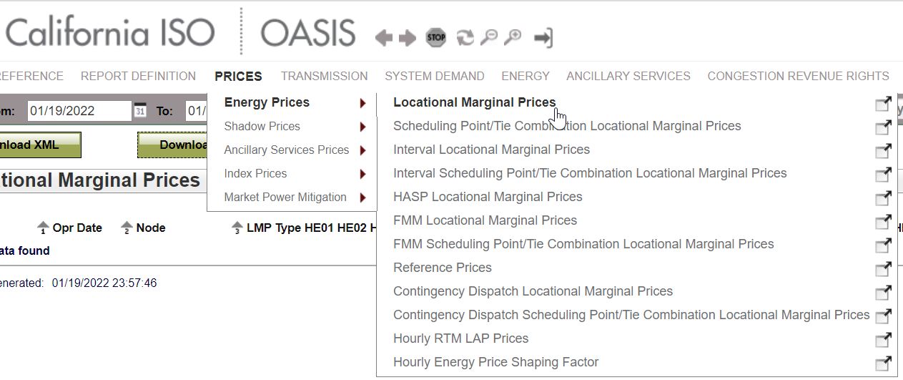

## Shadow Prices Reports

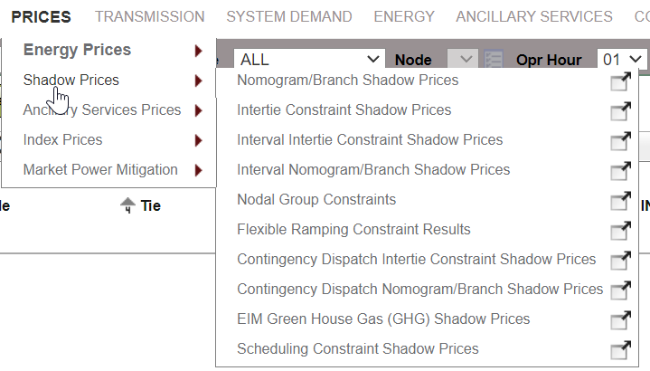

## Ancillary Services Prices Reports

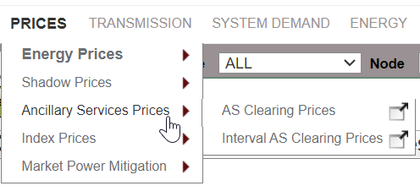

## System Demand Reports

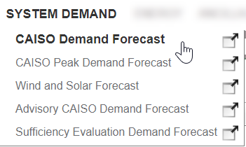

## Transmission Reports

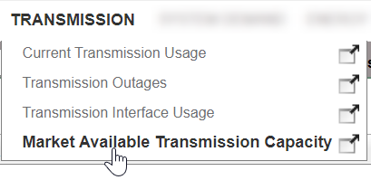

## Ancillary Services Reports

